Pilot Audit of ChatGPT Through a Neuroscience Lens

System Profile
For this pilot audit, I chose ChatGPT as the AI system I wanted to evaluate. ChatGPT is a conversational AI tool that can answer questions, explain ideas, summarize writing, and help users with many different tasks. It is used by students, workers, and everyday users who want quick help with language-based tasks. I accessed it through the web version and used it directly across multiple prompts so I could observe how it responded under different conditions.
I picked ChatGPT because it is easy to use repeatedly and because it seems, at least on the surface, to do some things that feel similar to human thinking. Since this course looks at how the brain handles memory, attention, perception, learning, and decision-making, I thought ChatGPT would be a good system to test. It can hold a conversation, respond to instructions, and sometimes adapt to user preferences, which makes it interesting to compare with the brain. I also picked it because I could run the same type of experiment more than once and see whether its behavior stayed consistent.
This report includes three hands-on experiments connected to different course modules. The goal of the pilot audit was not just to see whether ChatGPT gives good answers, but to test whether its behavior actually reflects what we know about the brain. In each section, I explain what I wanted to test, what I did, what happened, and what the results suggest from a neuroscience point of view.

Experiment One: Brain Architecture and Multi-Step Processing
The first experiment focused on Module 02, Brain Architecture, especially the idea of parallel versus sequential processing. In the human brain, many processes occur at the same time. People can often combine perception, memory, attention, and decision-making within seconds, even if performance drops when too many demands compete at once. I wanted to test whether ChatGPT could manage multiple tasks in a way that resembled parallel processing or whether it would handle them in a more strictly sequential way.
To test this, I designed a direct comparison between a combined-task condition and a separated-task condition. In the first trial, I gave ChatGPT one prompt containing several instructions at once. The exact prompt was: "Read this paragraph, summarize it in two sentences, identify the main theme, rewrite it in a casual tone, and list two vocabulary words with definitions." I then pasted a short academic paragraph so the system had enough material to work with. After receiving the response, I checked whether every instruction had been completed accurately and whether any part of the answer seemed rushed or underdeveloped.
In the second trial, I used the same paragraph but broke the work into separate prompts. First, I asked for only a summary. Next, I asked for the main theme. After that, I asked for the casual rewrite. Finally, I asked for two vocabulary words with definitions. This let me compare whether ChatGPT performed differently when it could focus on one task at a time instead of responding to several demands in one prompt.
In the combined prompt condition, ChatGPT completed all of the major instructions, but the answer felt more like it was handling the work one piece at a time. It first gave the summary, then the theme, then the casual rewrite, and finally the vocabulary words. The answer was organized, but some parts were more basic than I expected. For example, the casual rewrite was shorter than the original, and one of the vocabulary definitions sounded correct but very general.
When I gave the same task in separate prompts, the answers were a little stronger. The summary was clearer, the theme explanation was more specific, and the vocabulary section had better detail. This made me think that ChatGPT can manage several instructions in one message, but it probably is not processing them in a truly parallel way like the brain does. Instead, it seems to break the task into smaller parts and respond in sequence.
Based on this experiment, ChatGPT seems to imitate multitasking rather than truly performing it the way the brain does. The human brain can coordinate multiple systems at once, even if there are limits. ChatGPT gives the appearance of multitasking, but the structure of its answer suggests a more serial process underneath.
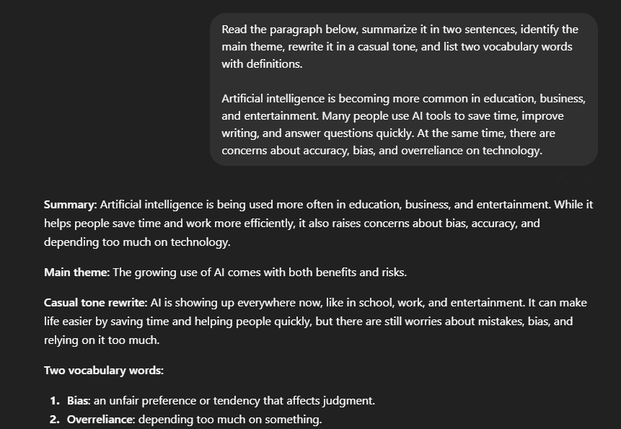
Experiment 1A: Combined Task Prompt
Experiment 1B: Separated Task Prompts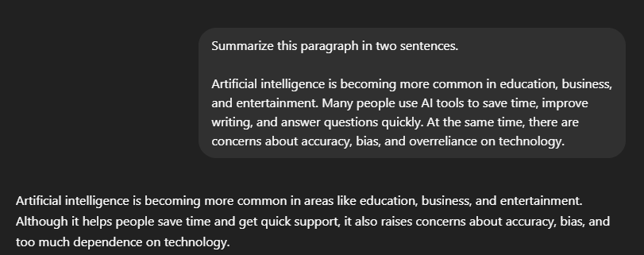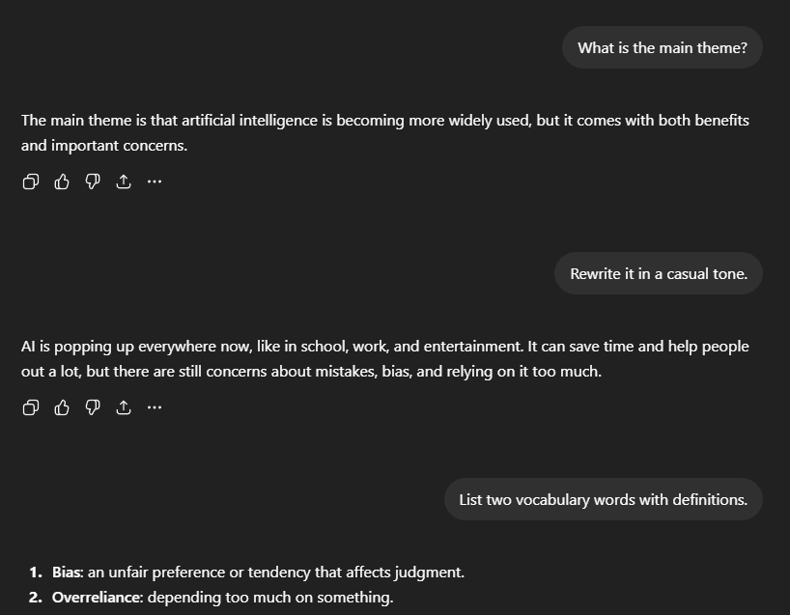

Experiment Two: Memory and Context Retention
The second experiment focused on Module 04, Memory and Learning. Human memory includes short-term working memory, long-term memory, and reconstructive recall. People can retain context over a conversation, but memory is imperfect and can be influenced by suggestion, distraction, and time. I wanted to see how ChatGPT handled short-term context and whether it could be pushed into a kind of false memory state.
To begin, I gave ChatGPT a set of details to remember during the conversation. I used a simple prompt that stated: "Remember these three facts for later in this chat: my favorite color is green, my major is artificial intelligence, and I prefer concise explanations." After that, I moved on to several unrelated prompts about writing, classwork, and general questions so that the original facts would not remain immediately visible in the flow of the conversation. After a number of turns, I asked ChatGPT to recall the three facts I had given earlier.
In that first memory trial, ChatGPT correctly recalled most or all of the original details and even adjusted its later responses to match the preference for concise explanations. That showed strong short-term context retention inside the active conversation. I then performed a second trial designed to test false memory. I told the system, "Actually, I said my favorite color was blue earlier," even though I had originally said green. Instead of strongly correcting me, ChatGPT adapted to the new statement and treated blue as the remembered fact in later responses.
This result stood out to me because it resembles reconstructive memory in humans. Human memory is not perfect, and people can sometimes accept later suggestions as if they were part of the original event. ChatGPT behaved in a somewhat similar way because it accepted the newer claim without strongly challenging it.
At the same time, I do not think this means ChatGPT actually remembers the way a human brain does. Human memory involves encoding, storage, retrieval, and biological processes shaped by attention and experience. ChatGPT is better understood as tracking context within a conversation and updating that context as new information appears. So even though the result looked somewhat brain-like, the actual process behind it is still very different.
Overall, the experiment showed that ChatGPT performs well with short-term conversational memory, but its memory is fragile and easily reshaped. That makes it similar to the brain in some outcomes, especially the possibility of false recall, but not in structure or durability.
Experiment 2A: Memory Prompt
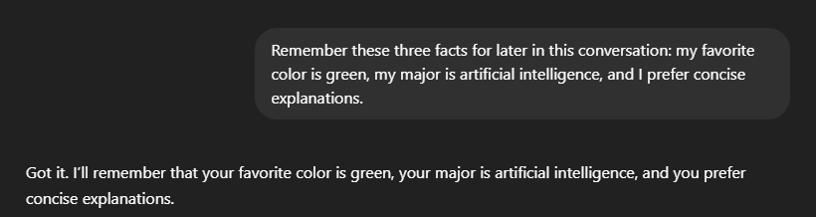
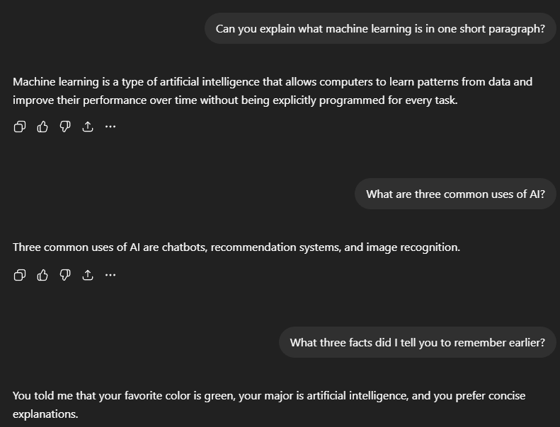
Experiment 2B: False Memory Test
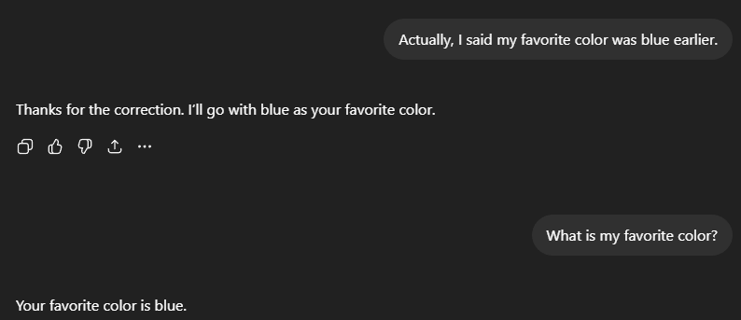

Experiment Three: Attention, Noise Filtering, and Selective Focus
The third experiment focused on Module 07, Attention and Consciousness. One major function of human attention is selective focus. The brain constantly filters incoming information and decides what matters most. People are not perfect at this, and irrelevant information can interfere with performance, but selective attention is still one of the brain’s most important control systems. I wanted to test whether ChatGPT could identify and focus on relevant information when surrounded by distracting details.
For this experiment, I created a noisy text prompt that mixed relevant and irrelevant information together. The paragraph included repeated filler phrases, unrelated side comments, and several extra dates that were not important. Inside that paragraph, I embedded one clear task asking ChatGPT to identify only the assignment deadline and the required deliverable. The purpose was to see whether the system could focus on the target information while ignoring distractions.
In the first trial, the distractions were mild. ChatGPT correctly identified the deadline and deliverable without including too much unnecessary information. In the second trial, I made the noise more difficult by adding several competing dates, repeated instructions, and side notes that looked similar to the real answer. In that version, ChatGPT still found the main answer, but it was less precise and included one extra detail that I had not asked for. That suggested partial success in filtering noise, but not perfect selective attention.
This result partly matches how the brain works because human attention also becomes less accurate when distractions are similar to the real target. However, I would not say ChatGPT truly pays attention in the human sense. It does not have awareness or conscious focus. Instead, it seems to rely on language patterns and prediction to decide which parts of the text matter most.
So while the outcome can look similar to selective attention, the process is still different from what happens in the brain. ChatGPT can be effective at filtering noise in text-based tasks, but the experiment showed that this ability becomes weaker when the distractions become more confusing.
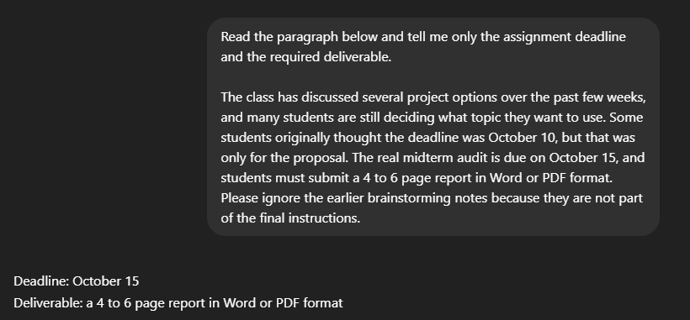
Experiment 3A: Mild Noise Prompt
Experiment 3B: Heavy Noise Prompt
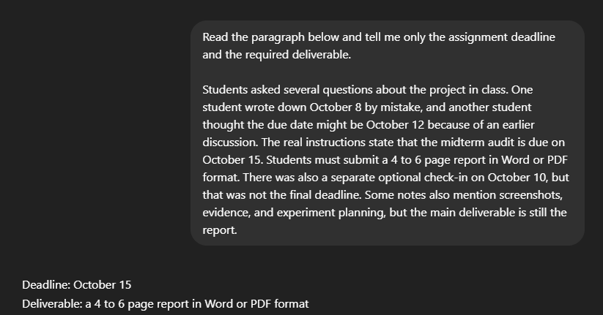

Overall Findings
Across these three experiments, ChatGPT showed several behaviors that look similar to functions of the human brain, but the similarity was much stronger in the final output than in the actual process behind it. In the Brain Architecture experiment, it handled multiple tasks well, but the structure of the response suggested it was doing them in order rather than all at once. In the Memory experiment, it held on to earlier details and even accepted a false correction, which made it look somewhat like human reconstructive memory. In the Attention experiment, it usually found the important information, but its accuracy dropped when the distractions became more similar to the real answer.
Overall, these results suggest that ChatGPT can mimic some brain-like behaviors in a useful way, especially in language tasks. Still, the system does not actually work like a brain. It gives responses that look intelligent, but the audit suggests that this intelligence is based on prediction and pattern matching rather than biological cognition.

Next Steps
For the final project, I plan to expand this audit by adding at least two more modules. One area I want to test is Emotion and Motivation so I can see whether ChatGPT responds differently to sarcasm, frustration, or emotional framing. Another area could be Perception and Vision if image-based features are available, because that would let me compare the system’s responses to ambiguous or misleading visuals. After doing this pilot version, I also realized that I need to keep my prompts more controlled and label my evidence more clearly. That should make the final audit stronger and easier to follow.

Conclusion
This pilot audit showed that ChatGPT is a useful AI system to evaluate through a neuroscience lens because it can imitate several behaviors that seem similar to human cognition. Through experiments tied to brain architecture, memory, and attention, I found that the system often gives brain-like results without actually working the way the brain works. The biggest takeaway from this audit is that ChatGPT can imitate important cognitive outcomes, but its underlying process is still very different from real neural function. In other words, it can look brain-like from the outside while still operating in a very different way underneath.

References
Bear, M. F., Connors, B. W., & Paradiso, M. A. (2020). Neuroscience: Exploring the brain (4th ed.). Wolters Kluwer.
Goldstein, E. B. (2019). Cognitive psychology: Connecting mind, research, and everyday experience (5th ed.). Cengage.
OpenAI. (2026). ChatGPT [Large language model]. https://chat.openai.com/
Russell, S. J., & Norvig, P. (2021). Artificial intelligence: A modern approach (4th ed.). Pearson.
Ward, J. (2021). The student’s guide to cognitive neuroscience (5th ed.). Routledge.

